TRUSTED AI EXTENSIBILITY
Secured MCP Registry
Governed discovery. Trusted execution. Continuous assurance.
A security and governance control plane for publishing, discovering and using MCP services across AI agents and LLM-powered applications.
Move from fragmented MCP adoption to governed innovation.
SecureMCP helps organizations decide which publishers, services and versions may be trusted—then continues to apply policy, monitor behaviour and preserve accountability while those capabilities are used.

Marketing Overview | July 2026
PureCipher

THE OPPORTUNITY

AI agents are becoming more capable. Their connections must become more governable.
Model Context Protocol makes it easier for AI applications to reach tools, APIs and enterprise systems. That speed creates value—but it also introduces a new governance question: which capabilities should an AI agent be allowed to discover and use, under what conditions, and with what evidence?

The risk of unmanaged MCP adoption
1. Unknown trust
A useful server can still have an unclear publisher, unreviewed version or excessive permissions.
2. Fragmented control
Teams can configure MCP services independently, creating inconsistent approval and security practices.
3. Static decisions
A service that was safe at installation may become risky as context, behaviour or credentials change.
4. Limited accountability
Without common provenance and audit records, important actions are harder to explain and investigate.
SecureMCP turns trust into an operating model.
It combines a governed registry with verification, policy, consent, runtime protection, lifecycle control and auditable evidence.

HOW IT WORKS

A simple path from publication to continuous assurance
SecureMCP creates one governed journey for publishers, AI applications and security teams.
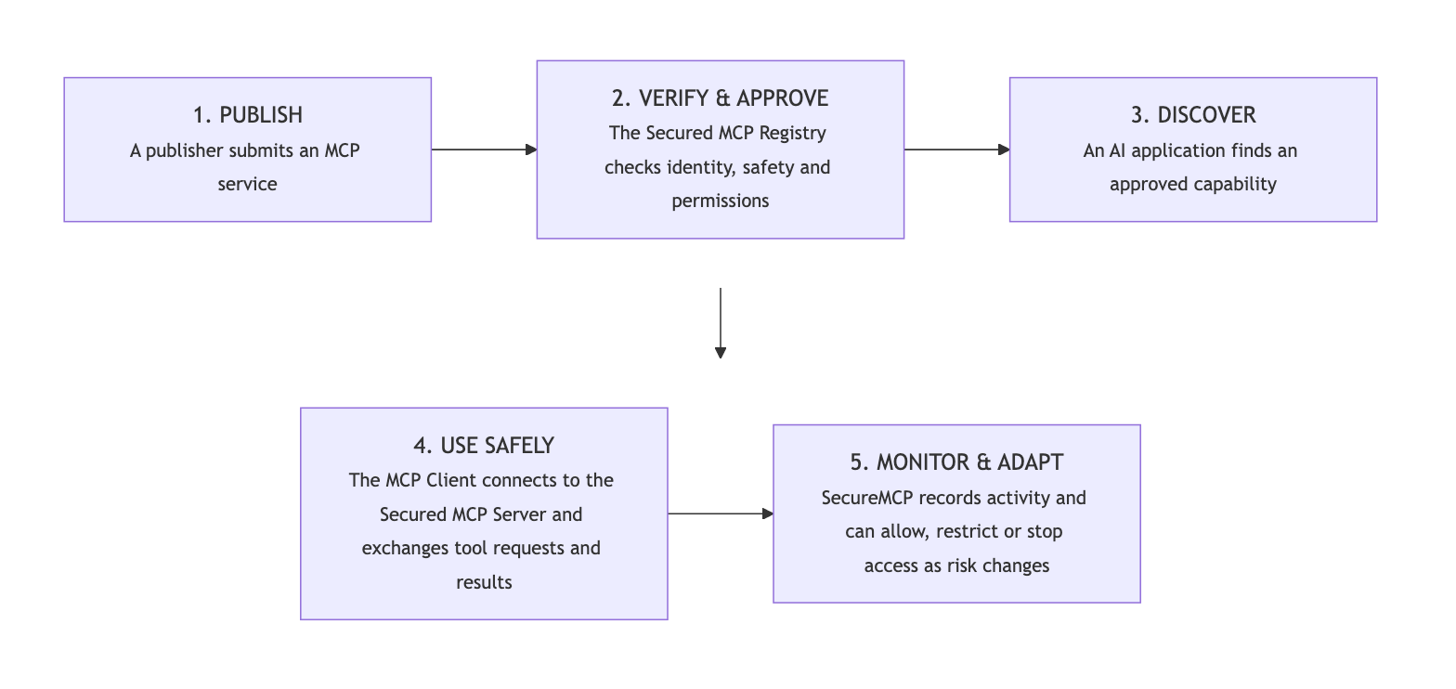
1. Publish
A publisher submits an MCP service with ownership, purpose, permissions and version information.
2. Verify and approve
Identity, safety evidence, certification and organizational requirements are checked.
3. Discover
Eligible AI agents and applications find approved capabilities through a trusted catalogue.
4. Use safely
The MCP Client connects to the approved server while policy and consent govern the requested action.
5. Monitor and adapt
SecureMCP records activity and can allow, restrict, require approval or stop access as risk changes.

WHY SECUREMCP

More than a directory: a governed control plane for MCP
1. Trust before discovery
Only approved publishers, services and versions become visible to the intended users and agents.
2. Policy during execution
A discoverable service can still be limited by user, agent, purpose, environment, data sensitivity or action risk.
3. Consent and contracts
Access reflects explicit authority and an agreed purpose—not installation alone.
4. Reflexive protection
The Reflexive Core compares current activity with expected behaviour and adapts the response when risk changes.
5. Traceable accountability
Provenance, audit, alerts and compliance evidence preserve who requested what, why a decision was made and what happened.
6. Lifecycle enforcement
Organizations can approve, suspend, revoke, deprecate or retire services and versions across their lifecycle.

The business result
Faster adoption with clearer control
Developers and business teams gain access to approved capabilities without repeating the same security review, while risk and governance teams retain a strategic control point.

BUSINESS VALUE

What organizations gain
1. Accelerated innovation
Publishers and internal teams can bring trusted MCP capabilities to users faster.
2. Reduced integration risk
Approved versions, permissions and identities replace ad hoc connections and unknown dependencies.
3. Consistent governance
One operating model can serve Claude Code, Codex and other standards-compliant MCP clients.
4. Audit-ready evidence
Important identities, decisions and outcomes remain available for review, investigation and assurance.

Representative use cases
1. Enterprise-approved AI tools
Business need: Employees want AI clients to use Jira, GitHub, databases and internal APIs.
SecureMCP value: Provide a curated catalogue of reviewed services and discourage or block unapproved alternatives.
2. Regulated financial-services agent
Business need: An AI agent analyzes customers or transactions using sensitive systems.
SecureMCP value: Apply purpose limits, consent, policy and audit evidence so access matches the approved task.
3. Healthcare workflow assistant
Business need: A clinical or administrative assistant needs controlled access to patient-related services.
SecureMCP value: Approve specific service versions and limit access by role, purpose and environment.

SECURE ADOPTION AT SCALE

Use cases across the MCP lifecycle
4. Third-party vendor onboarding
Business need: A SaaS provider wants its MCP service to reach enterprise AI agents.
SecureMCP value: Review publisher identity, capability, permissions and version evidence before publication.
5. High-risk production action
Business need: An agent requests a deployment, payment, account change or destructive infrastructure action.
SecureMCP value: Check policy and consent, use restricted execution where appropriate and stop abnormal behaviour.
6. Rapid incident response
Business need: A trusted version or publisher credential becomes compromised.
SecureMCP value: Revoke trust, suspend the listing, notify affected clients and prevent new connections.

From registry to control plane
Capability | Typical registry or catalogue | Secured MCP Registry
Discovery | Find and install available MCP servers | Discover approved services for the right audience
Trust | Publisher and package metadata | Identity, certification, attestation and version status
Access | Configured by the user or client | Policy, consent, contracts and client identity
Runtime | Connection and operational visibility | Continuous behavioural risk assessment and adaptive controls
Lifecycle | Publish, update or remove listings | Approve, suspend, revoke, deprecate and notify
Evidence | Logs vary by platform | Provenance, audit and compliance-ready records

DESIGNED FOR THE WAY ORGANIZATIONS OPERATE

One trust model. Multiple deployment choices.
1. Internal registry
Create a private catalogue of approved MCP services for employees, developers and enterprise AI agents.
2. Curated public service
Publish approved services to a controlled audience while maintaining certification and lifecycle status.
3. Federated trust environment
Share approved trust information across business units or partners while preserving local policy decisions.

Works across the MCP ecosystem
The Secured MCP Registry is designed to complement—not replace—the MCP standard and public ecosystem. Organizations can use public registries and catalogues as upstream sources, enrich that metadata with their own approval and security evidence, and serve multiple standards-compliant clients through one governed model.
The positioning is clear
Public directories optimize for broad discovery. SecureMCP optimizes for governed organizational adoption—before publication, during discovery and throughout execution.

Start with a focused adoption path
1. Choose a priority workflow
Select one valuable MCP-enabled use case with clear users, systems and business outcomes.
2. Define the trust requirements
Identify the publishers, versions, permissions, policies, consent and evidence required.
3. Publish an approved catalogue
Make trusted capabilities easy for eligible AI clients to discover and use.
4. Expand with evidence
Use runtime insight, audit records and operating experience to scale adoption responsibly.
SecureMCP
Trust the capability. Govern the action. Preserve the evidence.

